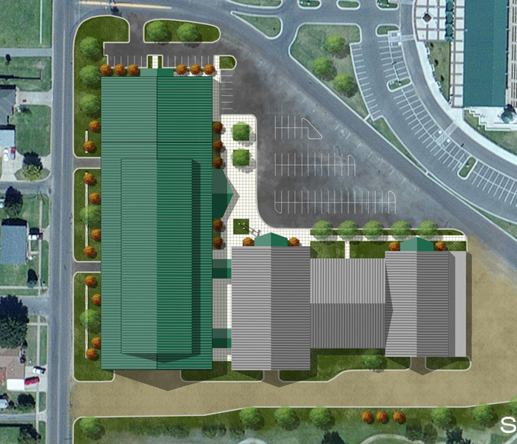

OCTOBER 19th, 20th & 21st

WOODWARD COUNTY EVENT CENTER
WOODWARD, OKLAHOMA

